A1 : Program to compute average of N nos

#include <stdio.h>

int main()

{

int n,number,sum=0;

float avg;

printf("Enter the number of integers : ");

scanf("%d",&n);

printf("Enter the integers : ");

for(int i=0;i<n;++i)

{

scanf("%d",&number);

sum+=number;

}

avg=(float)sum/n;

printf("The average is %f\n",avg);

return 0;

}

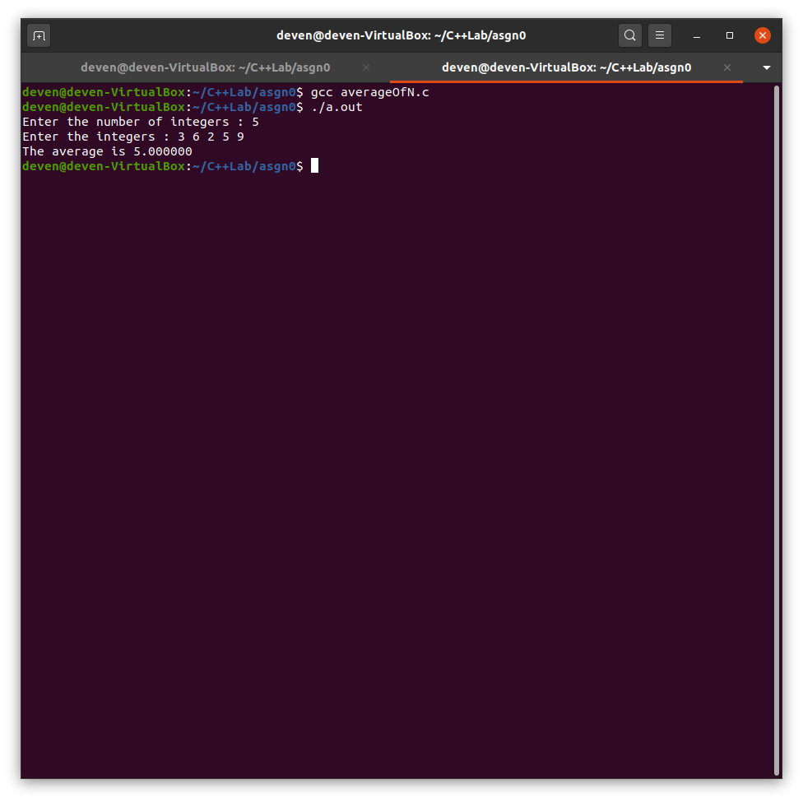

A2. program to add two matrices

#include <stdio.h>

void input_matrix(int m,int n,int matrix[][n])

{

for(int i=0;i<m;++i)

for(int j=0;j<n;++j)

scanf("%d",&matrix[i][j]);

}

void print_matrix(int m,int n,int matrix[][n])

{

for(int i=0;i<m;++i){

for(int j=0;j<n;++j){

printf("%d ",matrix[i][j]);

}

printf("\n");

}

}

void add_matrices(int m,int n,int matrix1[][n],int matrix2[][n], int sum[][n])

{

for(int i=0;i<m;++i)

for(int j=0;j<n;++j)

sum[i][j]=matrix1[i][j]+matrix2[i][j];

}

int main()

{

int m,n;

printf("Enter the m x n values:");

scanf("%d%d",&m,&n);

int matrix1[m][n],matrix2[m][n],sum[m][n];

printf("Enter the values of the first matrix:\n");

input_matrix(m,n,matrix1);

printf("The first matrix is:\n");

print_matrix(m,n,matrix1);

printf("Enter the values of the second matrix:\n");

input_matrix(m,n,matrix2);

printf("The second matrix is:\n");

print_matrix(m,n,matrix2);

add_matrices(m,n,matrix1,matrix2,sum);

printf("The sum of the 2 matrices is:\n");

print_matrix(m,n,sum);

return 0;

}

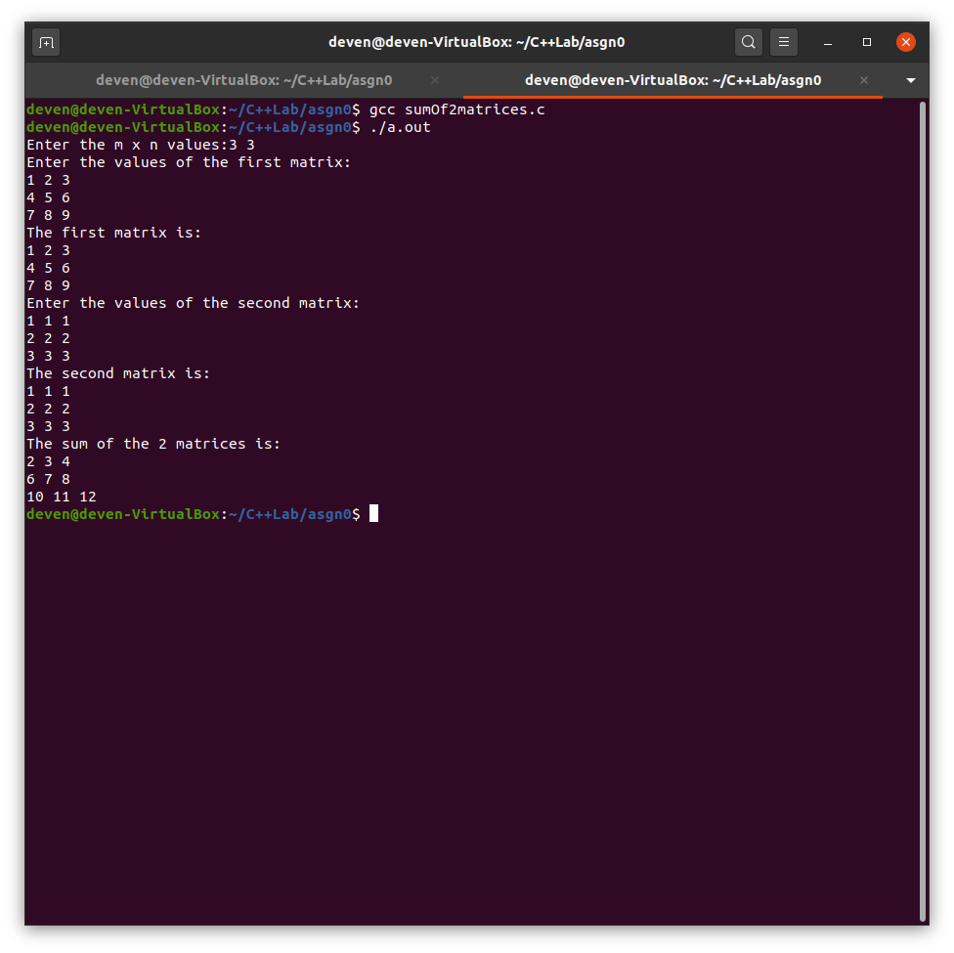

A3 :  Convert temperature in fahrenheit to Celsius

#include <stdio.h>

int main()

{

float Tf,Tc;

printf("Enter the Temperature in fahrenheit : ");

scanf("%f",&Tf);

Tc=(Tf-32)/1.8;

printf("The Temperatuer in celsius is %f\n",Tc);

return 0;

}

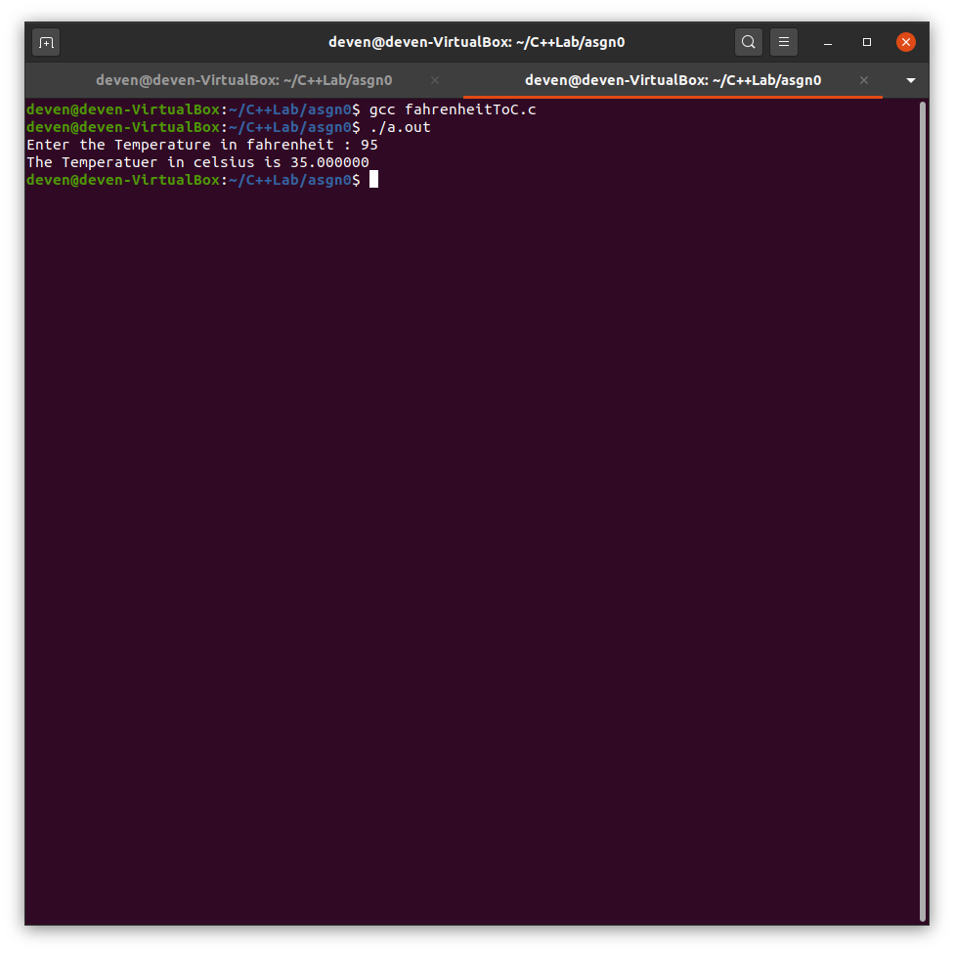

A4 : CONVERT DAYS TO MONTHS AND DAYS

#include <stdio.h>

int main()

{

int ndays,m,d;

printf("Enter the number of days:");

scanf("%d",&ndays);

m=(int)ndays/30;

d=(int)(ndays-m*30);

printf("The number of months=%d and days=%d\n",m,d);

return 0;

}

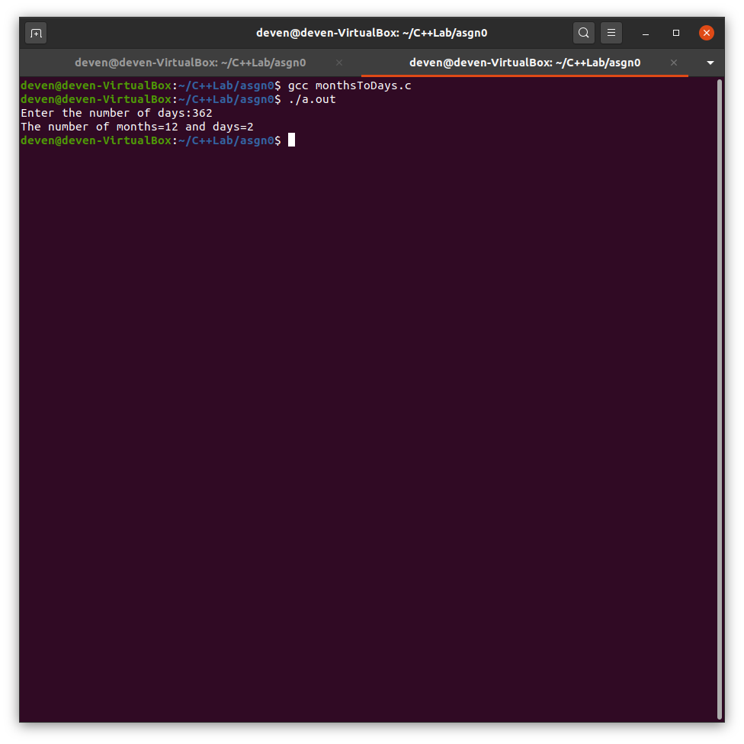

A5 : Inventory Report

#include <stdio.h>

struct product

{

char code[5];

int quantity;

float rate;

float value;

};

typedef struct product Product;

int main()

{

Product p[4];

float totvalue=0;

for(int i=0;i<4;++i)

{

printf("Enter the product %d code, quantity and rate:",i+1);

scanf("%s%d%f",p[i].code,&p[i].quantity,&p[i].rate);

p[i].value=p[i].quantity*p[i].rate;

totvalue+=p[i].value;

}

printf("Inventory report\n");

printf("Code Quantity Rate Value\n");

for(int i=0;i<4;++i)

printf("%s %d %.2f %.2f\n",p[i].code,p[i].quantity,p[i].rate,p[i].value);

printf("The total value is %f\n",totvalue);

return 0;

}

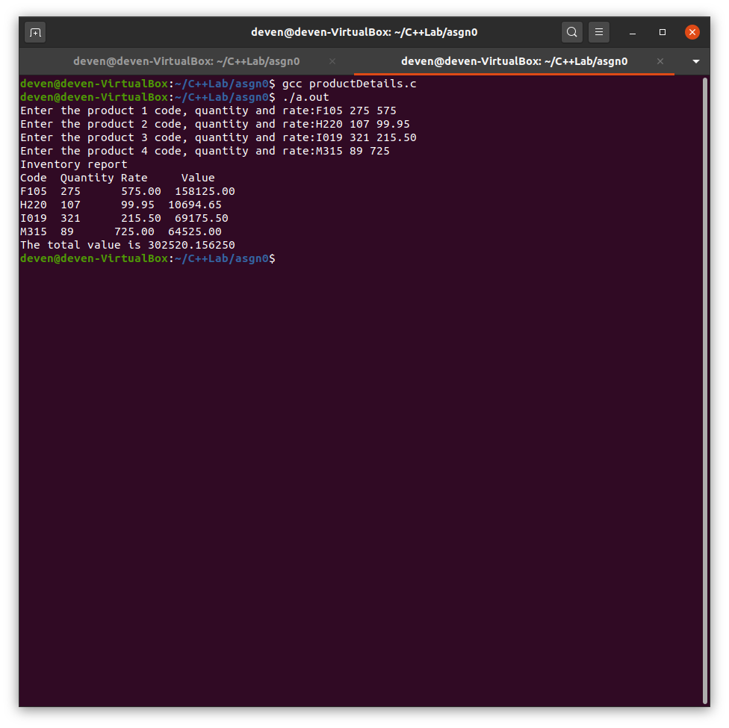

A6: Determine average cost and the range of values and range of a varying costs of computers (in hundreds)

#include <stdio.h>

int main()

{

float cost[10],avgcost,sum=0,hcost=0,lcost=0,range;

printf("Enter the different pc costs(In hundreds):");

for(int i=0;i<10;++i)

{

scanf("%f",&cost[i]);

sum+=cost[i];

}

avgcost=sum/10;

hcost=lcost=cost[0];

for(int i=1;i<10;++i)

{

if(cost[i]>hcost)

hcost=cost[i];

if(cost[i]<lcost)

lcost=cost[i];

}

range=hcost-lcost;

printf("The average cost(In hundreds) is %f and range is(In hundreds) %f",avgcost,range);

return 0;

}

